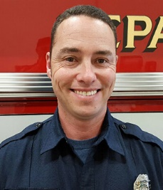
Bob Dirham
Bob Dirham works for the City of Kennewick Fire Department. He has been a career firefighter since 2001 and holds the rank of Captain for the department’s ladder company. Through his career, Bob has worked closely with his union, Local 1296 Kennewick as an E- Board member and Vice President. For Bob, the fight against cancer hits close to home, as he lost both parents to cancer related diseases. When Bob was asked to participate in a Washington State grant study that is today known as Healthy In Healthy Out., he did not hesitate. He is dedicated to helping figure out and pass along some of the best practices to reducing exposures related to fire service occupational cancers. Bob looks forward to passing on his knowledge to help slow the spread of cancer-related illnesses among our fire service brothers and sisters from across the country.

